Save a Place for an Older Face

These dogs have been loyal, faithful companions their whole lives through puppy antics, rowdy teenager, steady adults and now in their senior years they find themselves discarded, confused, alone, their whole world has changed. What happened? Where is my family? We have never turned away senior
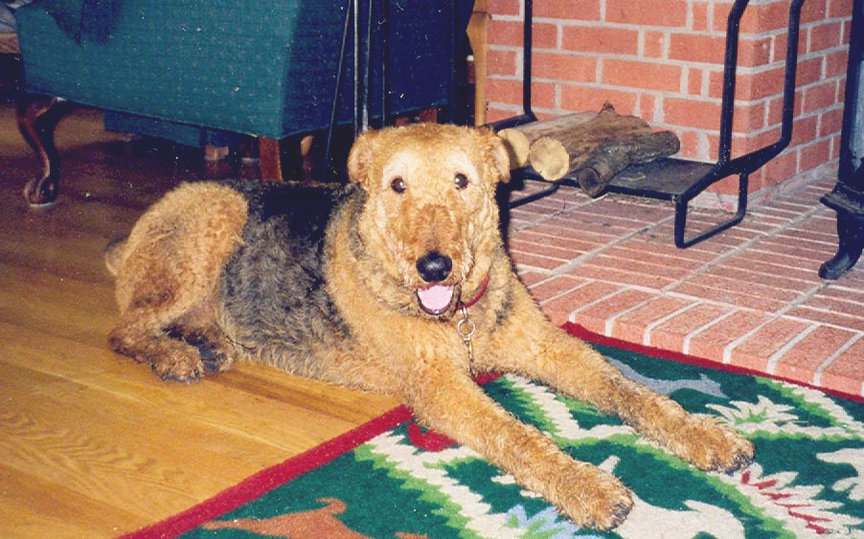
Airedales in need though many "rescues" do.

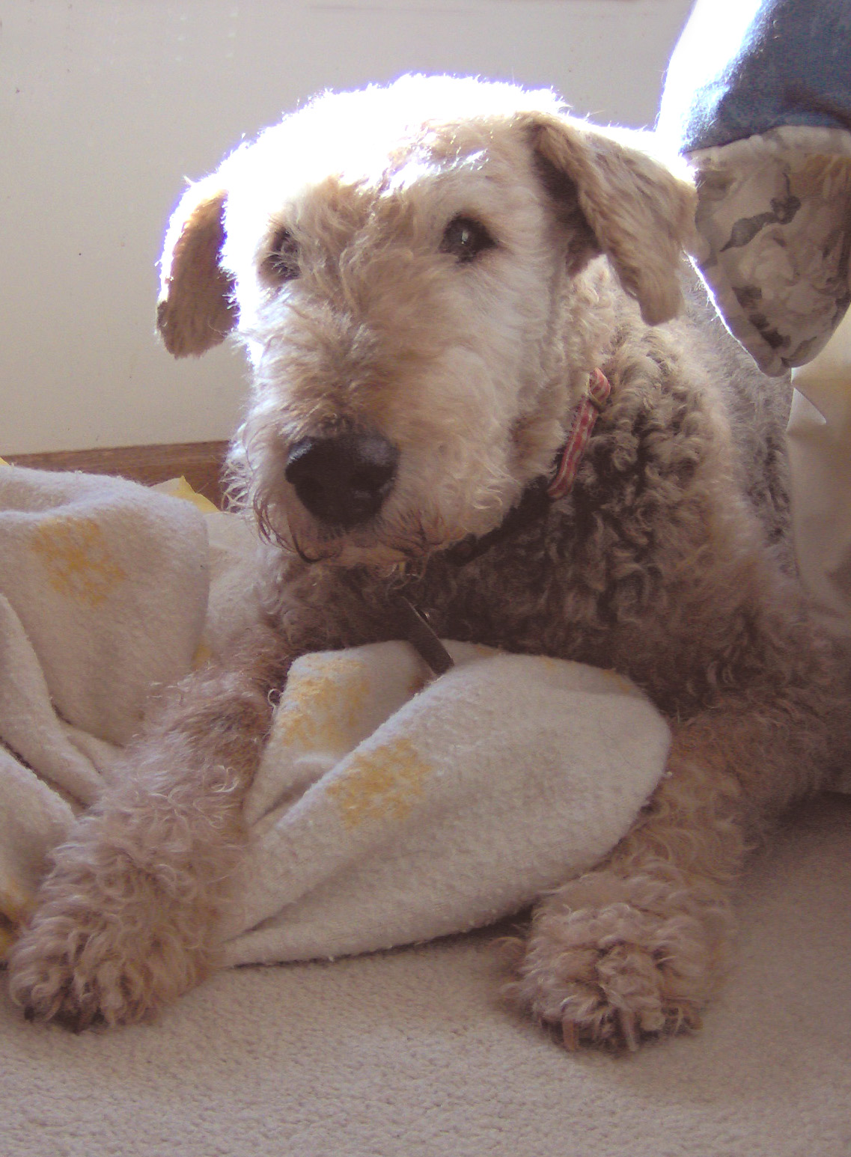
These senior citizens are a little slower, their eyes may be cloudy, they have a little arthritis, but they are so appreciative for the little kindness. It's a joy like no other when a discarded senior citizen rests their head in your lap, tail wagging and licks your hand. These dogs are not necessarily fraught with expensive medical conditions. They need a warm, safe place, a little extra padding for a bed and senior dog food. They don't expect to go for marathon runs, a sedate walk around the block will do just fine, thank you. They may sleep more and although they enjoy being couch potatoes, they still take pleasure in a new toy chew. They give lots of love and affection. You can give an older Airedale the opportunity to be loved . . . again or maybe for the first time in their lives.

Why Consider a Senior?

Think about yourself, your household and your activities. The benefits of adopting a senior Airedale may fit right in with any or all of these.

► I am a small person and could easily be
pulled over by an exuberant Airedale
dashing after a squirrel on our walks.
► I am a senior myself and may not be able
to physically handle the antics of a younger
Airedale.
► I have a physical reason that would make it
difficult for me to give a younger dog
enough exercise.
► I have another senior dog or a special
needs dog in the household who would not
take well to a younger dog pouncing on
them and trying to engage them in play.

What about health issues?


Many of our seniors may not have any medical issues at all. Others may only need something as simple as medication for incontinence or something for arthritis. These types of things are very affordable.

Occasionally we do get a senior who has medical issues over and above those of typical aging. We will be up-front about these issues and let prospective adopters know what they are in for. With the whole picture presented to them, we are usually able to find people willing to handle the issues

How much exercise?

While many seniors are just as happy being a couch potato, they would benefit from a moderate amount of exercise. Usually a short walk around the block is good for them.

Like any Airedale, seniors would benefit from a little obedience training – just a few basics. Many seniors have already had obedience training at some point in their lives. A senior may not have the energy to play exhausting games of fetch, but they usually love to “sit” for treats or “come” for a belly rub.

What about food?

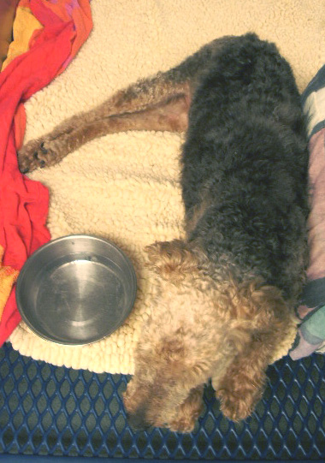
The best gift you can give your senior Airedale every day is to feed him quality dog food. The small extra cost is reflected in better health, fewer allergies, less itching and skin problems, smaller stools, and a shiny coat. Quality food starts with real food ingredients (lamb, chicken, turkey, rice and barley) and does NOT contain artificial color, flavors, sugar or salt to enhance flavor. Your dog will absorb more nutrients and therefore require less food. You should choose a dog food formulated for seniors. Many of these now contain Glucosamine and Chondroitin for joint health.

Better quality dog foods are found at pet supply stores, not the grocery store! These include Eukanuba, Science Diet, Nutro, ProPlan, and Nature’s Recipe. Dogs with skin and allergy problems will benefit from lamb and rice food, which is naturally preserved.

Some people like to give supplements to their senior dogs for joint health. You can get chewable tablets through your vet or the internet such as SynoviG3 that are not too expensive and are easy to give to your Airedale.

How long will they be with me?


This is a question that many potential adopters ask themselves when it comes to adopting seniors. While we realize that a senior will definitely have less time to spend with us than a younger Airedale, there are still no guarantees. We have seen younger dogs cross the bridge on occasion shortly after adoption, which is usually more painful because it is unexpected.

It does take a special person to look beyond the short time a senior might have to spend with you and see the appreciation and love in their eyes for quality time you can give them during those remaining years. Ask anyone who took in a senior. You won’t find any of them with regrets. Luckily, rescue continues to find these special people.

What about finances

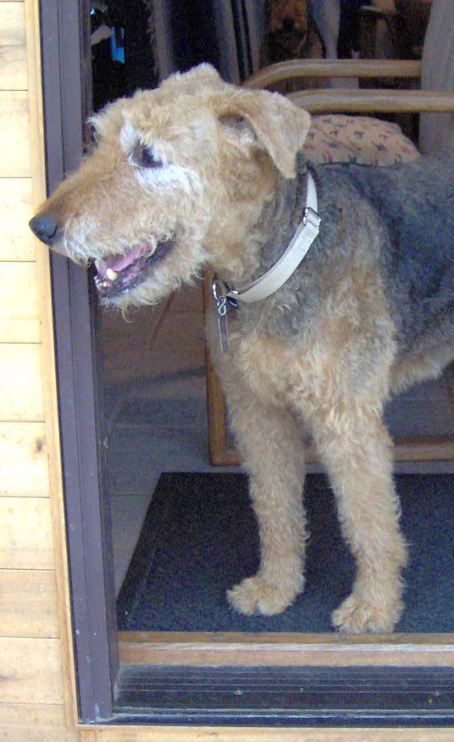
Adoption Donation
We realize that seniors are a little harder to place and may cost an adopter a little more money to take care of during their golden years. Because we do, we will often consider a smaller adoption donation or even waive the adoption donation to see a senior go to a loving home.

Additional Expenses
If you want to consider giving a senior a loving home but are concerned about the ability to afford a possible large vet bill, talk with us. We may be able to help out and can put something in your Placement Contract concerning an agreement for assistance. National Airedale Rescue also has a fund to help with expenses for Senior Airedales.

I am convinced – where do I start?

If you would like to give a home to a senior Airedale, please tell your state coordinator and indicate this on your application. It is as simple as that. We would be happy to talk with you.

Please
Consider
A Senior
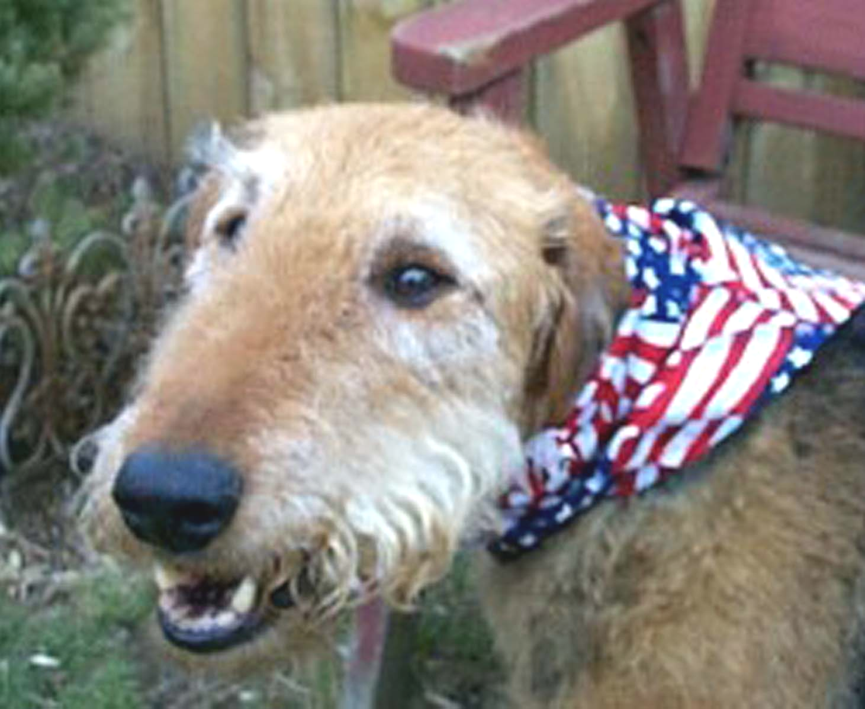

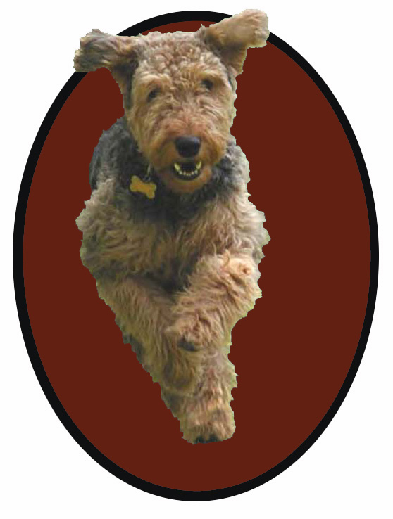



1123 Vesper Road, Ann Arbor, MI 48103
www.aire-rescue.com

