Airedale personality


Airedales are very devoted companions, but they fully expect to be an equal partner in your life. They seem to have a sense of humor about themselves and you, so you had better develop the ability to see humor in all situations. Like when they steal your keys just as you are about to leave for work and run around the back yard with them daring you to try and catch them. Airedales do not respond well to being excluded from family life. You cannot expect an Airedale to be happy and well adjusted if he/she is confined to the backyard or to a single room in the house.

Airedales are not for the faint at heart


The very qualities that make Airedales "the only breed" for some of us, make them the most undesirable to others. They are very smart and often extremely stubborn. Possessing a real thought process as well as a sense of humor; Airedales are even capable of pulling practical jokes. Few people appreciate being the objects of gleeful deception, especially by their dog, but that appreciation is one of the basic necessities of owning an Airedale.

Training

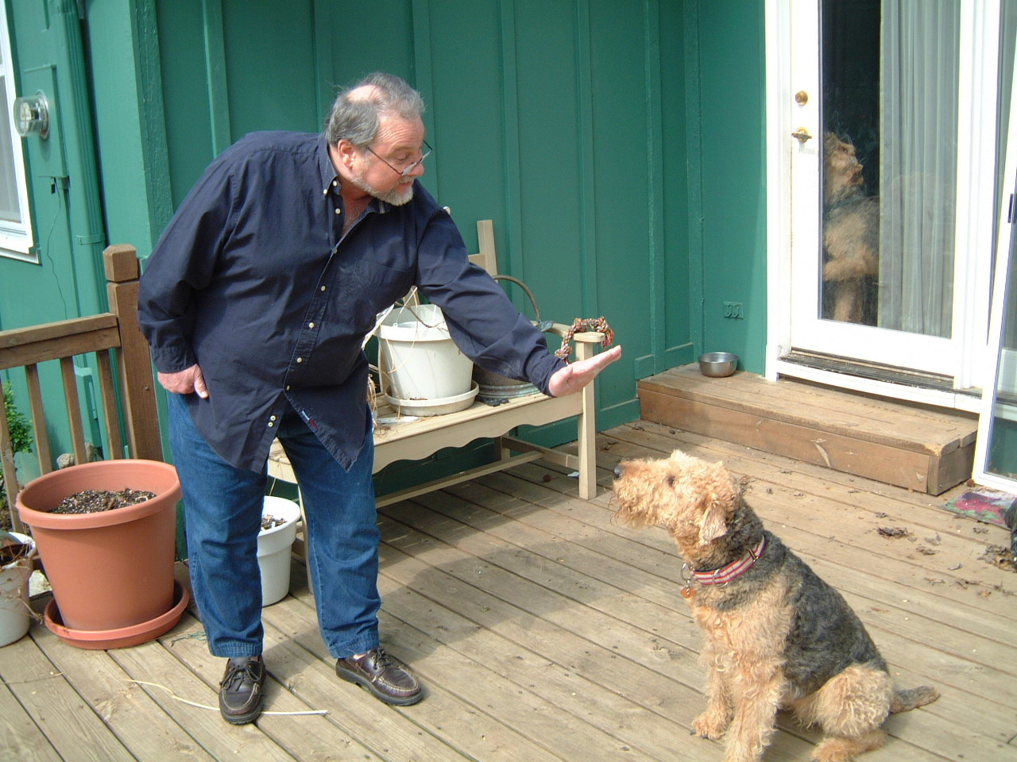
While Airedales are very smart, they are not always obedient! They can almost always find something much more important to do than
come when called.
Airedales do not respond well to heavy-handed training methods. Training efforts are most successful if they are based on praise rather than punishment.
Your Airedale wants to work with you not for you. Your training methods will have to take this attitude into account. Some breeds will joyfully do the same task repeatedly, not Airedales! Drills and repetitive exercises are met with less
than an enthusiastic response.
An Airedale likes to show off and demonstrate how smart they are - once! Their attitude is, "I did it and I did it perfectly! If you were not paying attention, then that is your problem!" However, there are Airedales that excel in fly ball, obedience, agility, hunting, search and rescue, police and therapy work. You as the owner, just have to learn what motivates your dog.

Grooming

Many people are drawn to an Airedale because of their appearance. Well groomed, Airedales are truly stunning. Other people are attracted to Airedales because they "don't shed". Actually they don't shed much, provided they get proper grooming.
Proper Grooming: Daily to weekly their coats need to be brushed or they get very matted. You should also check ears and teeth at least weekly. Every 6 - 10 weeks your dog will need to be clipped or hand striped. Most pet Airedales are clipped. Depending on where you live this will cost about $50 to $70 per dog. Hand stripping is usually only done for show dogs, since it is a lot of work and takes several weeks to complete. The old coat is slowly pulled out and as the new coat grows back it is usually
darker.
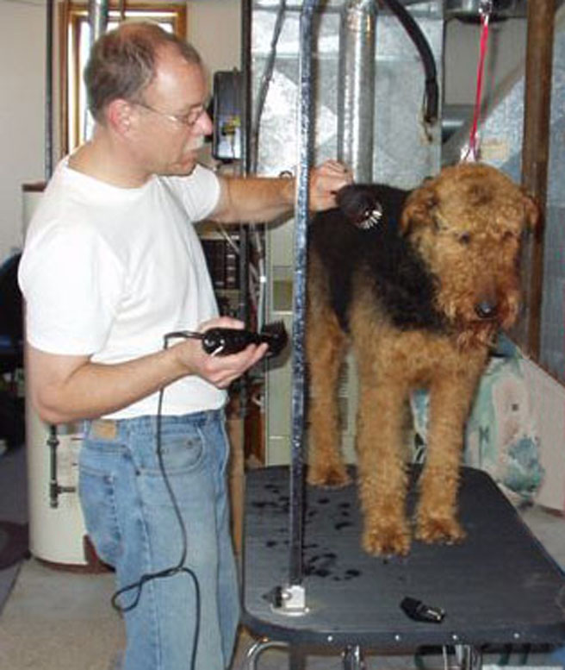
Not all grooming shops do a great job with Airedales. A badly groomed Airedale is not a pretty sight. You may want to learn how to do it yourself. Not only will you save money, but also you'll be spending some wonderful quality time with your dog. We have a pamphlet to assist you in learning how to groom your own dog.

Allergies and shedding

Some people have heard that because Airedales shed very little that they are good for people with dog-related allergies. While this can be true for some people, there are others who are quite allergic the dander of some Airedales.
If you, or someone in your family is allergic to dogs and you are considering an Airedale for this reason, please let us know.

An Airedale’s reputation

Airedales are terriers and like all terriers it is natural for them to chase small animals such as squirrels. It is never a given that Airedales will get along with cats. Extreme care must be taken when introducing an Airedale into a home with small animals such as cats or ferrets. They should always be supervised in these situations. Be sure to tell us about all the other animals in your dog's environment, those that live with you as well as those that visit.
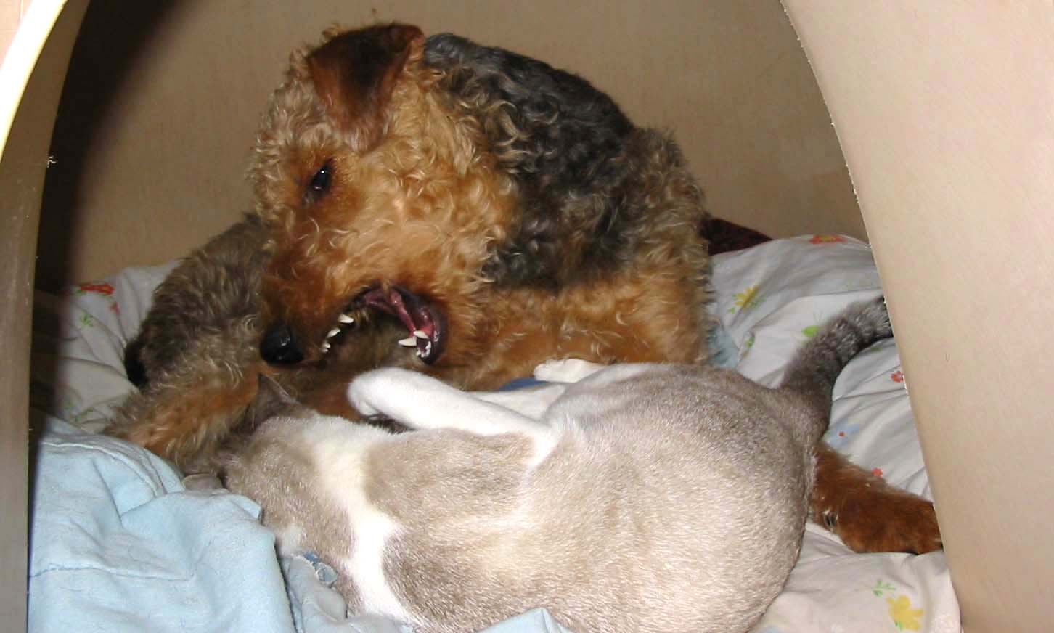

Lovable traits / Common objections

Beards: Many (non-Airedale) people object to an Airedale's drippy beard after a drink of water.
Digging: Airedales are terriers and so are very often avid diggers. They dig not so much outward, as down, so that they can have a comfortable "nest". They love gardens. They especially love lying in the middle of them smelling and eating the flowers. This is just one more reason to give them their own fenced in area.
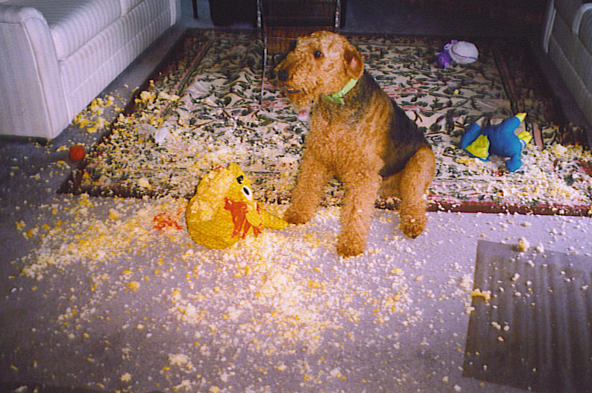
Paper products: Airedales seem to take special delight in the redistribution of toilet paper and tissues. You learn very quickly not to leave these items out. There is nothing like discovering that your Airedale has just redecorated your living room with remains of a full box of tissues, ten minutes before your guests arrive for dinner.
Trashcans: It may be a trashcan to you, but to an Airedale it is a toy box. You can avoid these fun clean ups by keeping the lids closed or putting the cans out of reach.
Stealing: Airedales are master pickpockets and collectors of human memorabilia. They teach you very quickly to pick things up and put them away. Oh and they will never look more innocent or become more deaf as when you are frantically searching for an item you need immediately.
Chewing: Airedales can be great chewers. Furniture, clothes, shoes, walls - it's all the same to them. One person left their new Airedale in the laundry room when they went to work. Upon their return they found the dog stretched comfortably on the sofa, very happy to see them. How did he get out of the laundry room? Very simple, he just chewed a hole in the wall to the kitchen.
Energy: There are some exceptions, but Airedales tend to be non-stop motion machines. Most breeds calm down a great deal as they get older. Airedales, while they do show the effects of age, tend to stay very energetic their entire lives. We've know 13 year old dogs who have leapt off the top of the stairs to chase intruders, like squirrels, out of their yards.

Are you ready for an

Airedale?
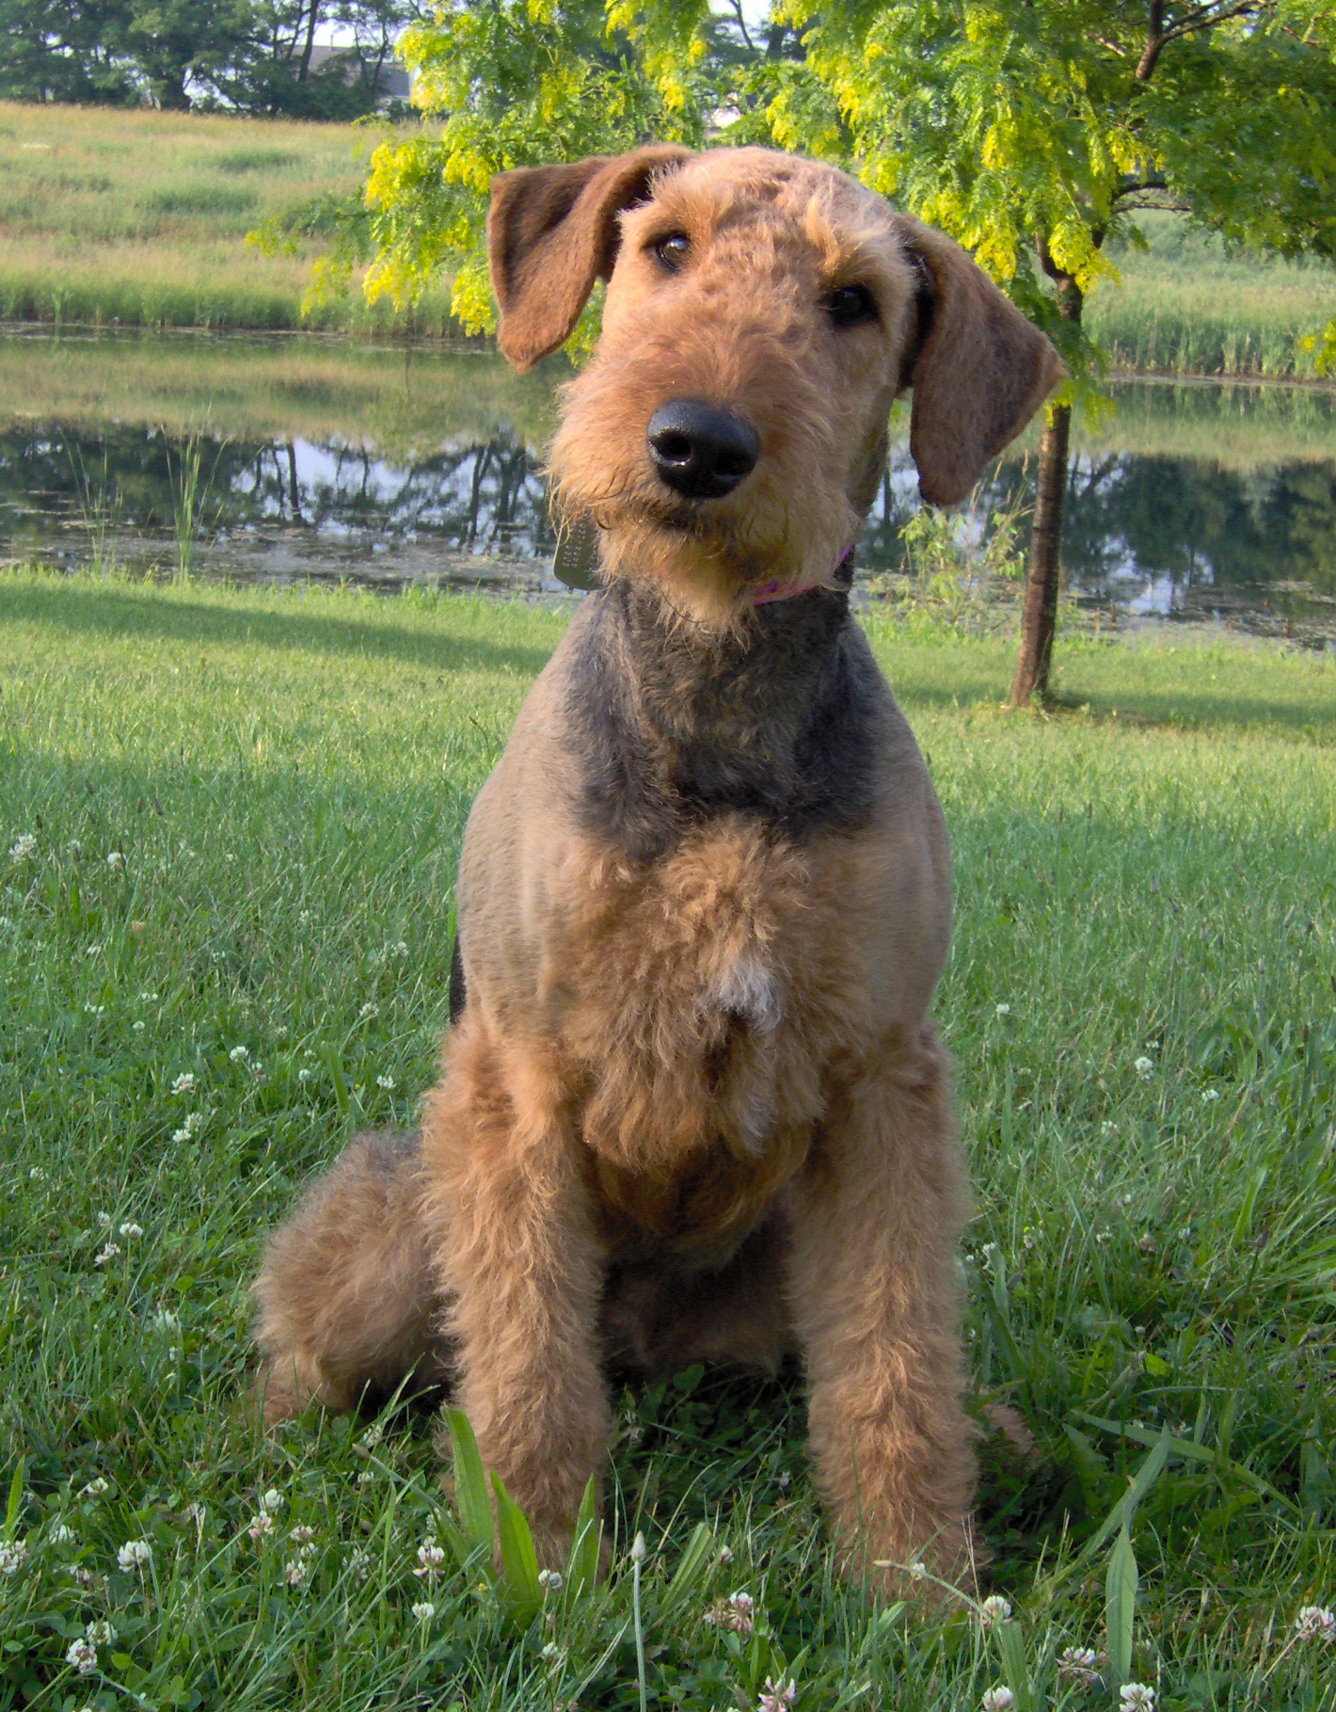




1123 Vesper Road, Ann Arbor, MI 48103
www.aire-rescue.com

